**Day 3 - API Integration Report – ShopCo**

**Steps to Integrate and Migrate Data to Sanity**

**1. Create a Project in Sanity**

* Start by creating an account on [Sanity](https://www.sanity.io/).
* Create a new project from the Sanity dashboard.

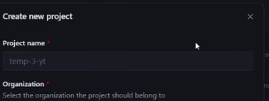

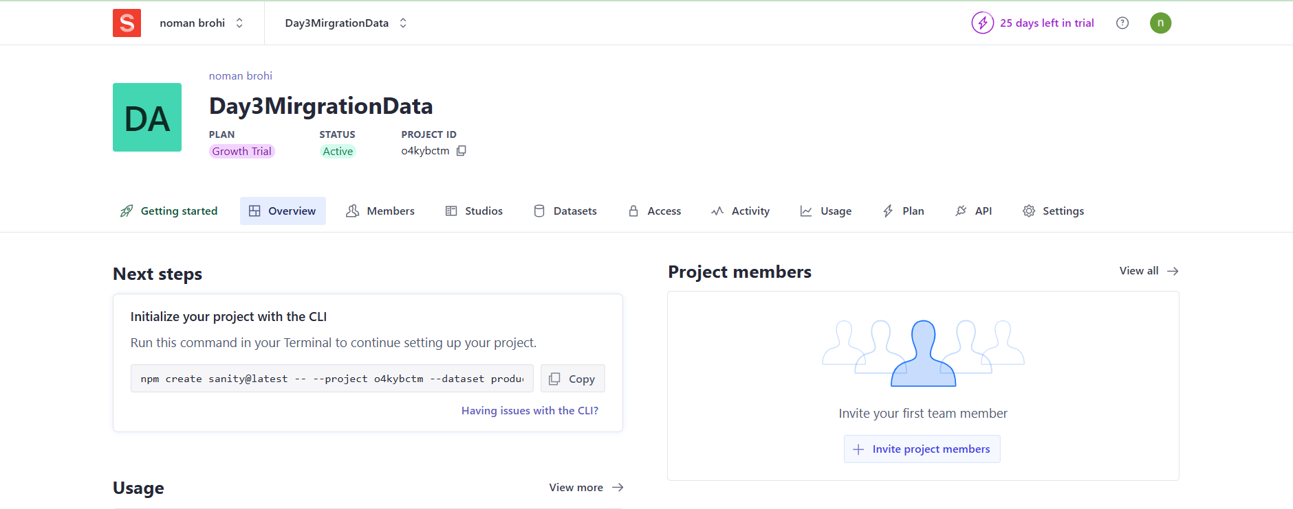

**2. Install Sanity CLI**

* Use the provided command to install the Sanity CLI:

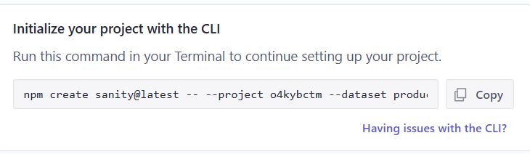

**3. Generate an API Token**

* Navigate to the API section in the Sanity dashboard.
* Generate a new token and copy it for later use.

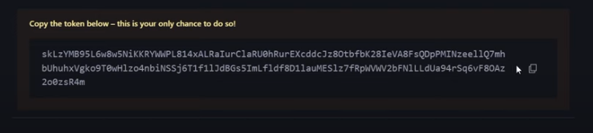

**4. Set Up Environment Variables**

* Create a .env file in your project root directory.
* Add the following environment variables:  
  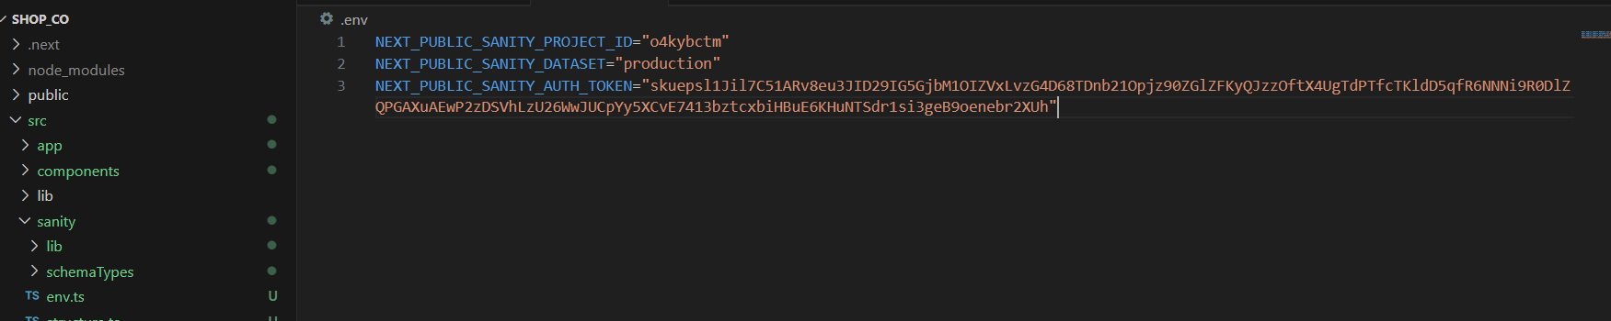

Also add sanity project id and data set

**5. Add Schema for Products**

* Go to the sanity folder in your project.
* Create a new file at sanity/schemaTypes/product.ts.
* Paste the provided schema code into this file.  
  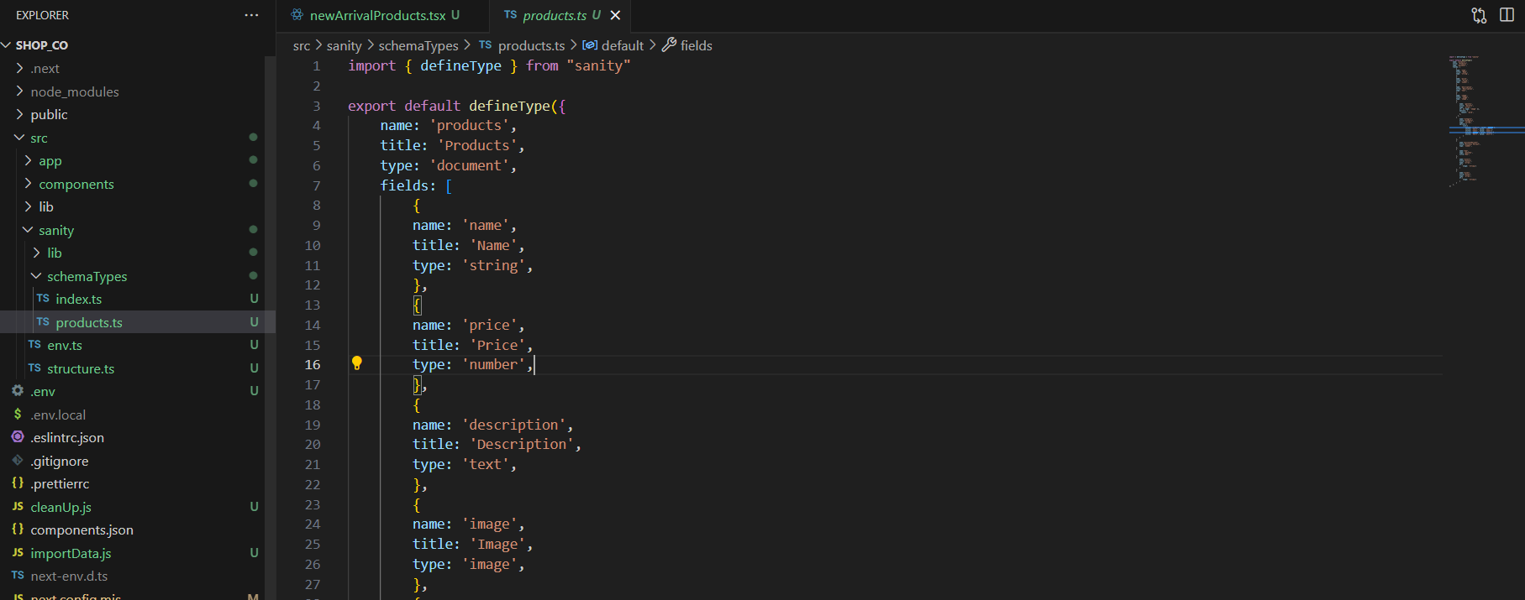

**6. Set Up Data Migration Script**

* Create a new file importData.ts in the project root directory.
* Add the given script for migrating data from the API to Sanity.



**7. Run the Data Migration Script**

* Execute the script to migrate data:

node importData.js

* Verify that the data has been successfully migrated.

**8. Verify Migration in Sanity Studio**

* Open Sanity Studio to confirm the migration:

http://localhost:3000/studio

* Check that all data has been properly migrated.  
  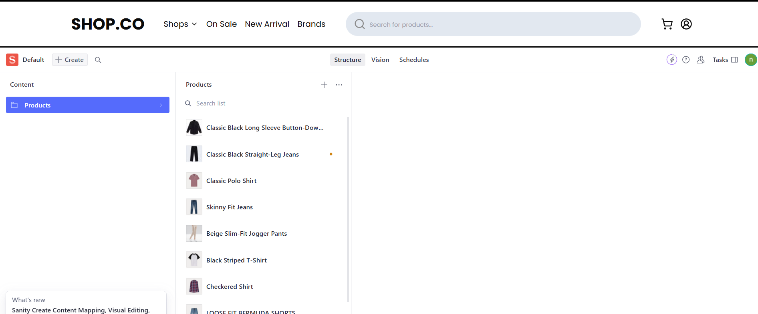

**Error Catching :**

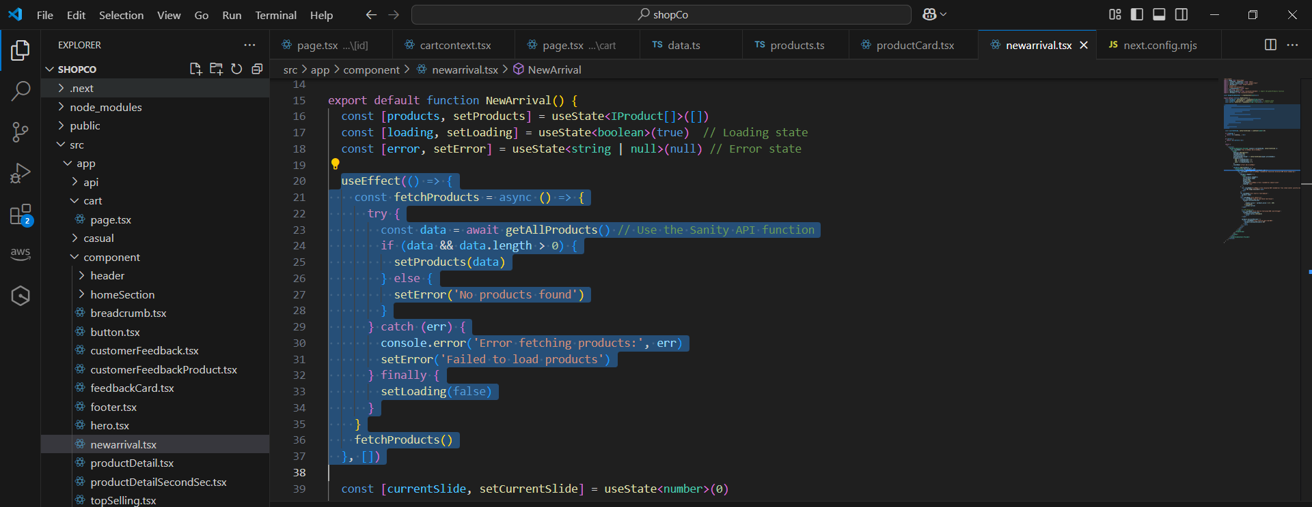

**Final Notes**

* If you encounter any issues during the migration process, double-check your .env file configuration and ensure your API token, project ID, and dataset name are correct.
* The data should now be available in Sanity Studio and ready for further development.